Vbase Exhibitor Guide 2018

Section B - Horncastle Arena

SECtion B - Table of Contents

1. Section B - Table of Contents 1
2. Welcome to Horncastle Arena 2
3. Emergency egress 3
3.1. Horncastle Arena Emergency Exit Map 3
4. How to Make Deliveries to Horncastle Arena 4
4.1. Freight Deliveries - Sending Goods to the Venue 4
4.2. Freight Collections - Sending Goods from the Venue 4
5. Venue restrictions 5
5.1. LPG and other Flammable Gas Restrictions 5
5.2. Utilities (Water and Waste) 5
6. Pack In/Out Information 6
6.1. Access Times 6
6.2. Where to Park 6
6.3. Arena Compound / Loading Dock Location 6
6.4. Map of the Arena Compound 7
6.5. Pack in / out via Arena front doors or the Lot 55 Café 7
6.6. Pack in / out via South Concourse doors 7
6.7. Storage Onsite 8
6.8. Forklift 8

Welcome to Horncastle Arena

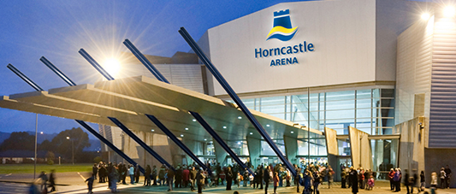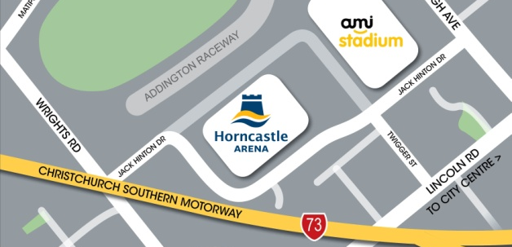

Horncastle Arena is one of New Zealand’s largest purpose built indoor entertainment and sporting venues and is host to Christchurch’s major events. Many of the world’s leading artists, performers and sports teams play here, attracting fans from throughout the country.

Easily located in Addington, it has over 4,000m2 of space ideal for exhibitions, tradeshows and large scale special events however can adapt easily to host many mid-sized events.

To find out more about the Horncastle Arena, visit our website http://vbase.co.nz/venues/horncastle-arena

Location
Horncastle Arena
55 Jack Hinton Drive
Addington
Christchurch

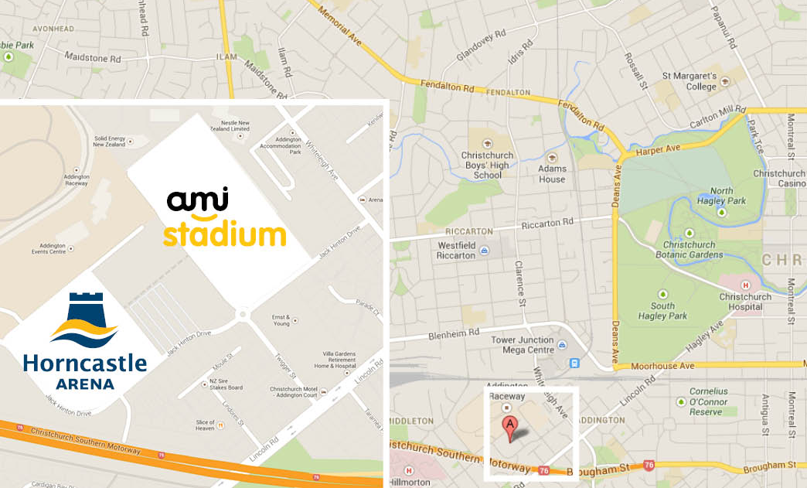

Emergency egress
A fully compliant evacuation scheme is maintained onsite designed to enable the successful evacuation of staff and visitors in the case of a fire or other emergency. Boards displaying the emergency procedures are located throughout the venue with maps to assist in directing you to your closest exit from that point. It is good practice to observe where the nearest emergency exit is in relation to your stand when arriving onsite.

Remember, stay calm and make your way to the nearest exit. Vbase staff will assist in the evacuation of the venue should this become necessary. Please follow the instructions of Vbase staff at all times.

Horncastle Arena Emergency Exit Map

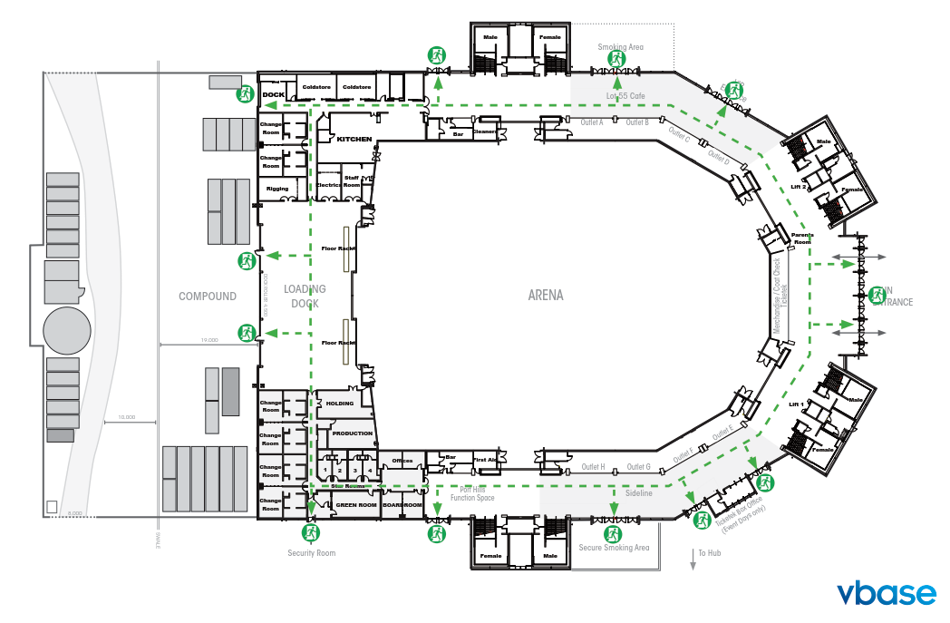

How to Make Deliveries to Horncastle Arena

Freight Deliveries - Sending Goods to the Venue

All goods delivered to any Vbase venue must display the Vbase event specific delivery consignment note filled out and attached to all items of freight. Please print out the Arena Incoming Delivery Label supplied with this guide.

Due to limited storage onsite, deliveries will only be accepted one working day prior to the pack in of your event.

It is the responsibility of the individual exhibitor to arrange the freight of all material to and from the venue, incurring all relevant charges (including GST and customs clearance charges). Any goods incurring charges will not be accepted by Vbase and will be held by your Freight Company and/or customs pending payment. This may cause you several days delay in clearance and receiving your goods.

Whilst all care will be exercised, Vbase accepts no responsibility for items delivered to or left within the venue before and/or after an event.

Freight Collections - Sending Goods from the Venue

Exhibitors are responsible for the removal of all goods from their stand after the event.

At the conclusion of your event, please ensure that all items are carefully packed, have the Vbase dedicated consignment notes attached and are left at your stand. Please ensure you bring all relevant packing equipment for your freight – the venue does not have these supplies onsite.

Please ensure you have arranged a courier to pick up your freight and have provided them with relevant delivery and contact details. Please attached the supplied Arena Outgoing Delivery Label consignment note to each individual parcel or item being collected.

Due to limited storage space, goods left on site after an event will only be held at the venue for no longer than 3 working days.

Venue restrictions

LPG and other Flammable Gas Restrictions

The Horncastle Arena has LPG gas restrictions therefore exhibitors requiring gas cylinders must submit full details to the exhibition organiser as soon as possible. The exhibition organiser will submit these details to the Vbase Event Coordinator for approval 14 working days prior to the event.

Each application is assessed with the safety of the public as its prime prerequisite.

Gas cylinders delivered on-site will be refused if the delivery was made without prior approval of the exhibition organiser and Vbase.

LPG cylinders shall not exceed 9kg in size with a maximum of two per 3m x 3m stand. There is an overall limitation of the amount of gas allowed in the building at any one time, therefore it is important you register your requirements with your exhibition organiser. If extra gas bottles are found that Vbase have not been made aware of, will be removed immediately as this compromises the venue's insurance coverage.

The installation and use of gas appliance and gas cylinders shall be undertaken in accordance with New Zealand AS/NZS 1596:2008 The Storage and Handling of LPG Gas AS 5601 – 2004 Gas Installations.

Utilities (Water and Waste)

Water connections and waste systems can be made available from specific locations inside the Arena. Please discuss any requirements you may have with your Vbase Event Coordinator at least one month (30 days) before the event.

It is the responsibility of the exhibitor to arrange connection from the service point to the equipment and this must be done by a licensed plumber. Vbase must be satisfied that the work undertaken has been done to a high standard. The connection size is 15-20mm.

Pack In/Out Information

Access Times

Please familiarise yourself with the agreed access times that have been allocated to your event. Your exhibition organiser will provide you with the designated pack in / pack out times.

Entry to the venue outside of these times is prohibited.

Entry to the venue will only be permitted to persons who have completed a Vbase site induction as per Section A of this guide.

Where to Park

Each event will have its own dedicated parking area for exhibitors. Please refer directly to your exhibition organiser for the correct location for this event. All exhibitors must park in this area during the entire event.

Please note that it is up to each exhibitor to ensure they park in the correct, dedicated area. Cars parked in other areas may be towed or clamped at the owner’s expense.

Arena Compound / Loading Dock Location

Horncastle Arena has one Loading Dock located at the rear of the venue Compound via an access gate. This gate will be open for the duration of the dedicated pack in / pack out hours.

To allow the safe movement around and access for all exhibitors the following conditions apply to all exhibitors using the compound during pack in / out:
- A strict 20 minute parking limit applies within the compound for drop off / pick up of goods during the pack in / pack out process.
- Only ONE vehicle is allowed in the compound at any one time per exhibitor.
- As soon as the vehicle is unloaded / loaded it must be immediately removed to the allocated exhibitor parking area
- Do not park on any yellow lines or in front of coned off areas.
- The directions of any Vbase staff must be followed at all times.

The specifications of the loading dock access doors are:
- External loading dock door is 4820mm high x 8100mm wide
- Internal arena access door is 4500mm high

Map of the Arena Compound

Pack in / out via Arena front doors or the Lot 55 Café

To ensure all visitors, staff and guests are kept safe we cannot allow pack in via the Arena main entrance or through the Lot 55 Café as these are public areas and this puts undue risk on members of the public using these areas.

Importantly the front main entrance is the primary emergency egress route and cannot be blocked at any time.

Please use the Arena Compound or South Concourse doors for all pack in / out activity as per clauses 6.3 and 6.6.

Pack in / out via South Concourse doors

For events that use the South Concourse for exhibition displays, pack in/out access is available via the South Concourse doors for exhibitors with stands in this area providing the following guidelines are adhered to:

- No vehicles, trolleys or equipment are to obstruct any emergency exits or egress routes
- The area in front of Ticketek Box Office must be kept clear at all times
- Pack in/pack out is only carried out during the designated time as confirmed by your exhibition organiser
- The dimensions of the South Concourse doors are:
  - Height 2.23m
  - Width 1.53m
- Upon request, and scheduled, South Concourse doors can be removed:
  - Width 3m

Storage Onsite

There are no storage facilities onsite at Horncastle Arena unless this is arranged by the exhibition organiser. Exhibitors are advised to make provision for the removal of all materials not required for their stand for the period of the event to other premises.

Forklift

There is limited forklift availability onsite, access to which is shared between all exhibitors and venue operations staff. Only forklift drivers who have the appropriate forklift licence and have received a forklift specific induction from a trained Vbase employee can use forklifts within Vbase Venues

All forklift drivers must wear an orange high-visibility vest and seatbelt whilst using the forklift.

The venue forklift specifications are:
- 3 tonne forklift which is rated to a maximum lift of 1.5 tonnes
- Fork lengths are 1200mm in length

If your requirements exceed the above specifications or if you require extended use of a forklift, please contact your exhibition organiser for approval to hire additional dedicated forklift(s).

