DELIVERY ADDRESS:  HORNCASTLE ARENA  55 Jack Hinton Drive, Addington,  Christchurch, New Zealand  Via Security Compound |  | 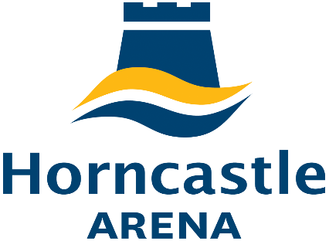 |  | 
EVENT NAME: | GPCME |  |  | EVENT # |  | 21448
EVENT DATE: | 13/08/18 - 19/08/18
HORNCASTLE ARENA Onsite Delivery Contact Number |  |  |  | +6427 669 6445

CONSIGNMENT DETAILS
Sender: |  |  | Sender Phone:
ONSITE  CONTACT NAME: |  |  | Onsite PHONE:
Company Name: |  |  | STAND #
Courier Name | Description of Items (eg cartons, pallets, boxes of satchel inserts etc) |  |  |  | Item No. |  | Of
DELIVERIES ACCEPTED
One working day prior to Event Day
MONDAY – FRIDAY 8.30am – 5pm and all day during event days

Please note: Vbase may sign delivery receipt documentation on behalf of the sender and / or receiver, however Vbase accepts no liability or responsibility in relation to any deliveries received or sent from any Vbase Venue.

