PICK-UP ADDRESS:  HORNCASTLE ARENA  55 Jack Hinton Drive, Addington,  Christchurch, New Zealand  Via Security Compound |  | 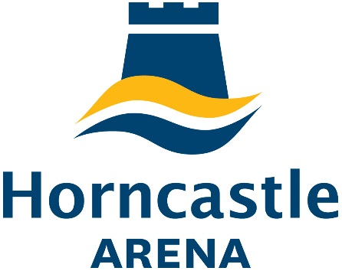 |  | 
Event Name | GPCME |  | Event Date | 16/08/20
HORNCASTLE ARENA onsite deliveries phone number +6427 669 6445

RETURN DELIVERY DETAILS
(Please ensure all items are securely packaged and all paperwork required by Couriers is attached eg. Shipment Air Waybills and sufficient Pre-paid stickers)
COMPANY NAME:

DELIVERY ADDRESS:

CONTACT NAME: |  |  | PHONE:
Courier Name: | Description of Items (eg cartons, pallets, boxes of satchel inserts) |  |  | Item No. | of
DELIVERIES MUST BE PICKED UP ONE DAY POST EVENT
MONDAY – FRIDAY 8.30am – 5pm
Please note: Vbase may sign delivery receipt documentation on behalf of the sender and / or receiver, however Vbase accepts no liability or responsibility in relation to any deliveries received or sent from any Vbase Venue.

