

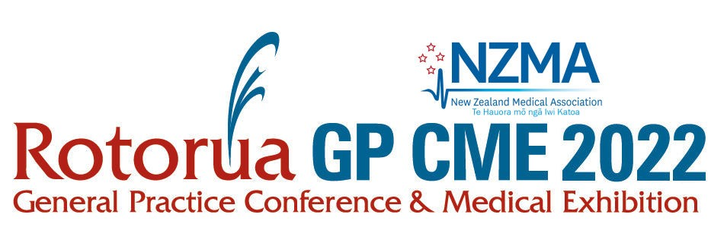

20 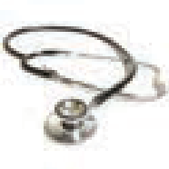 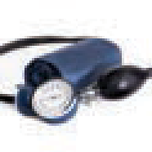 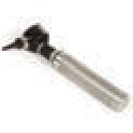
08-11 June 2023
Rotorua Energy Events Centre

TO:
Rotorua Energy Events Centre
Queens Drive, Government Gardens Rotorua 3010
New Zealand
Box Number of
FROM: SENDER DETAILS
Company Name: Address:
Contact Person:
Phone No: Email:

Event Name:
Venue:
GP CME 2023
Unison Arena
All goods to be received from: Mon 05 June 2023
Exhibitor Name: Stand No:
Contact Person on the day: Mobile No:

Delivery & Storage: The Rotorua Energy Events Centre will not permit any goods to be delivered to the
venue earlier than the date specified above. Deliveries prior to this date will be turned away.
All equipment/brochures must be picked up by 5pm Monday 12 June 2023. Any material still uncollected
by this date will be deemed unwanted and disposed of appropriately.
Event Venues (Rotorua Energy Events Centre) Ph +64 (0)7 349 5141

